**Raspberry pi 3B+ Setup and Installation Raspbian OS**

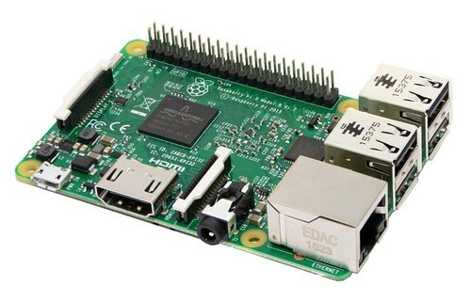

How to install Raspbian on the Raspberry Pi

Installing Raspbian on the Raspberry Pi is pretty straightforward. We’ll be downloading Raspbian and writing the disc image to a microSD card, then booting the Raspberry Pi to that microSD card.

### Step 1: Download Raspbian

I promised to show you how to install Raspbian on the Raspberry Pi, so it’s about time that we got started! First things first: hop onto your computer (Mac and PC are both fine) and download the Raspbian disc image.

I promised to show you how to install Raspbian on the Raspberry Pi, so it’s about time that we got started! First things first: hop onto your computer (Mac and PC are both fine) and download the Raspbian disc image.

**Download Rasbian click here**

### Step 2: Unzip the file

The Raspbian disc image is compressed, so you’ll need to unzip it. The file uses the ZIP64 format, so depending on how current your built-in utilities are, you need to use certain programs to unzip it. If you have any trouble, try these programs recommended by the Raspberry Pi Foundation:

* Windows users, you’ll want [**7-Zip.**](http://www.7-zip.org/)
* Mac users, [**The Unarchiver**](http://unarchiver.c3.cx/unarchiver) is your best bet.
* Linux users will use the appropriately named [**Unzip**](http://www.info-zip.org/mans/unzip.html).

### Step 3: Write the disc image to your microSD card

**[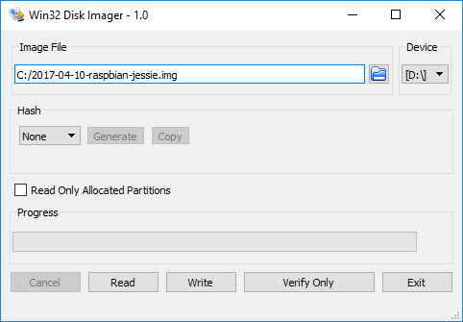](https://thepi.io/wp-content/uploads/2017/05/win32-disk-imager-raspbian.png)**

### Step 4: Put the microSD card in your Pi and boot up

Once the disc image has been written to the microSD card, you’re ready to go! Put that sucker into your Rasberry Pi, plug in the peripherals and power source, and enjoy.

* Create SSH.txt empty file and paste in SD card
* Create “wpa_supplicant.conf” file and type this program

ctrl_interface=DIR=/var/run/wpa_supplicant GROUP=netdev

update_config=1

country=PK #Your country code

network={

ssid="your network name" #Your WiFi Name

psk="your network passwrd" #Your WiFi password

key_mgmt=WPA-PSK

}

**Scan Ip Address Using Advance Ip Scanner**

* **Conect systm to Raspberry pi using LAN cable**
* **Now Click on Scan**

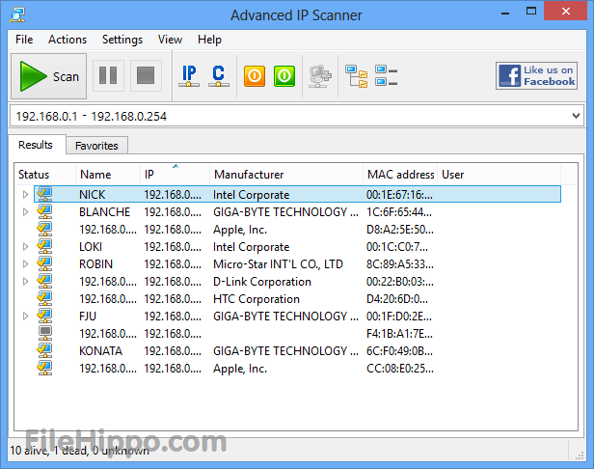

**Download Putty and Open it.**

**Enter your IP and than click open option**.

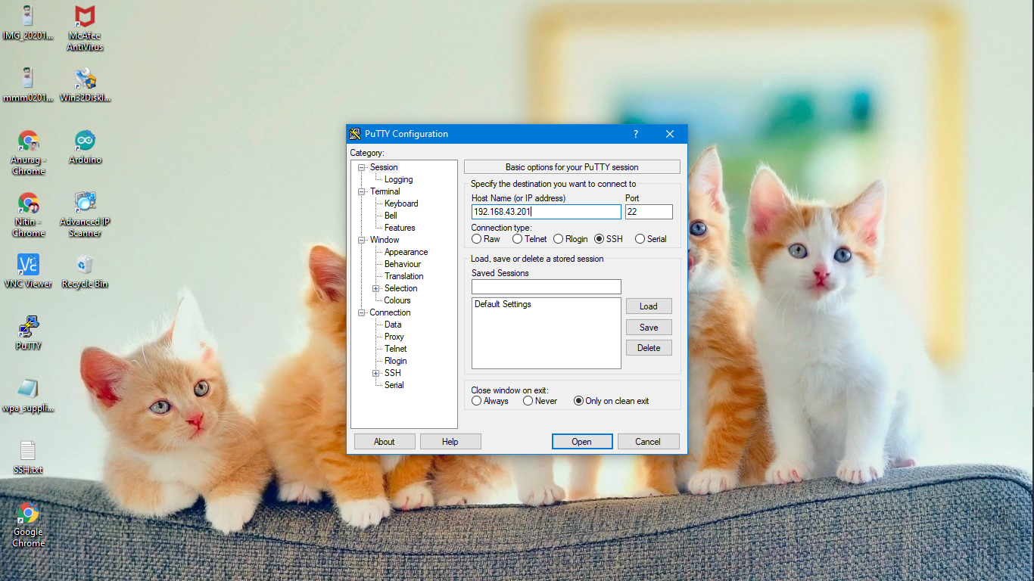

**Enter User ID and Password**

* **Raspbian by default User id is : pi**
* **Raspbian by default User Password is: raspberry**

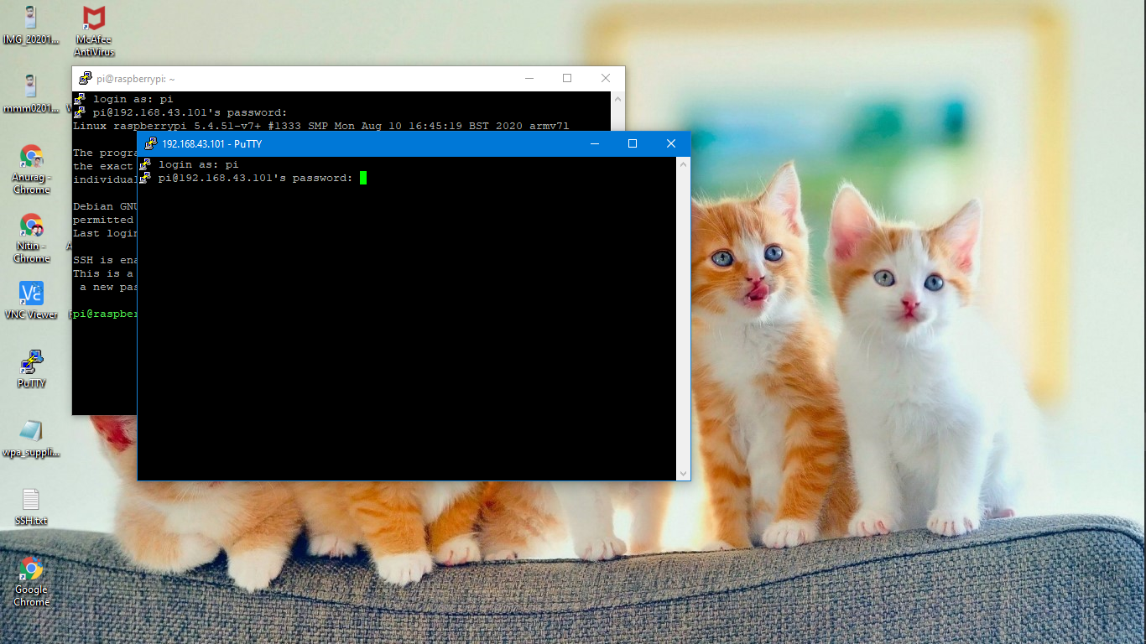

**Type : $ sudo raspi-config**

**Now Open System Config File**

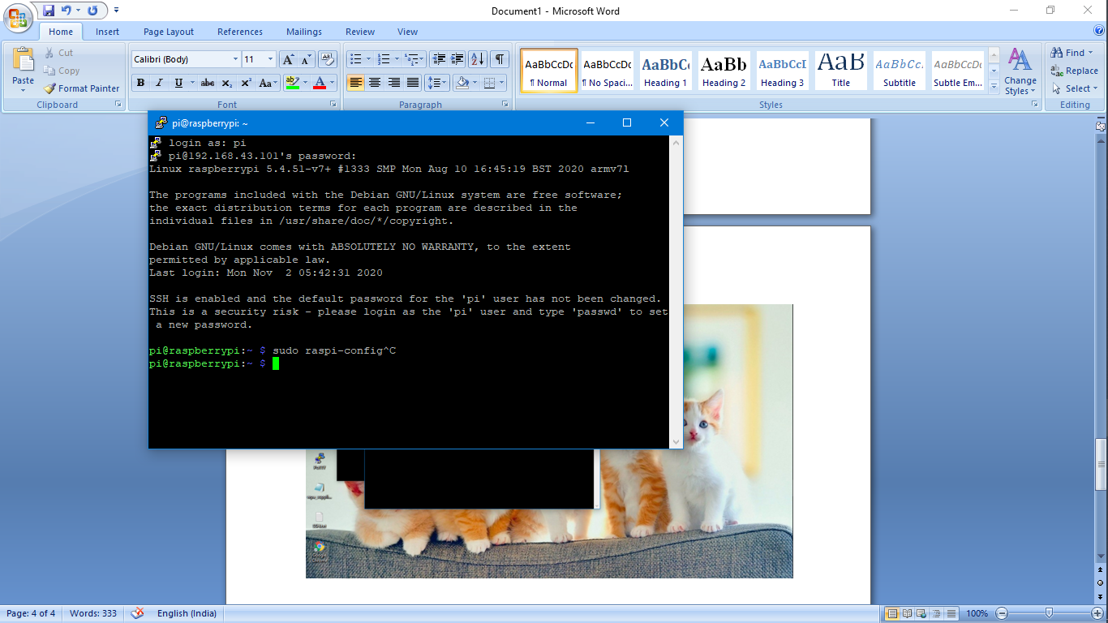

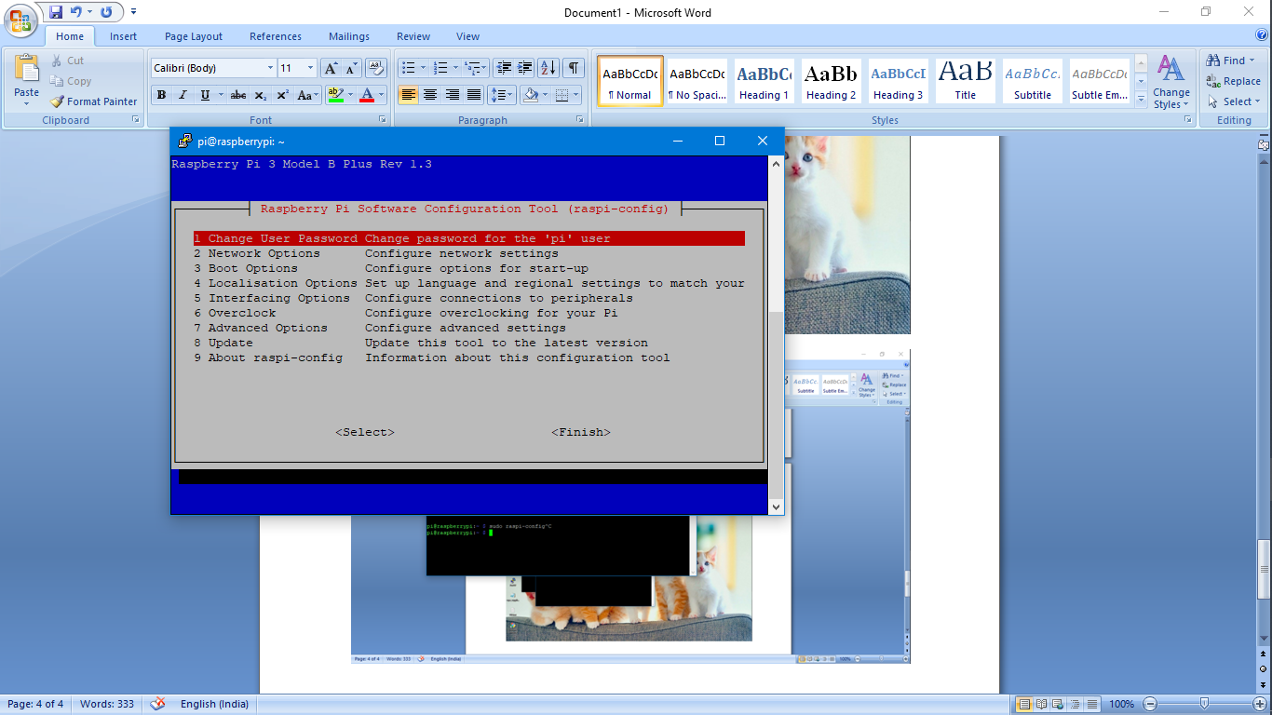

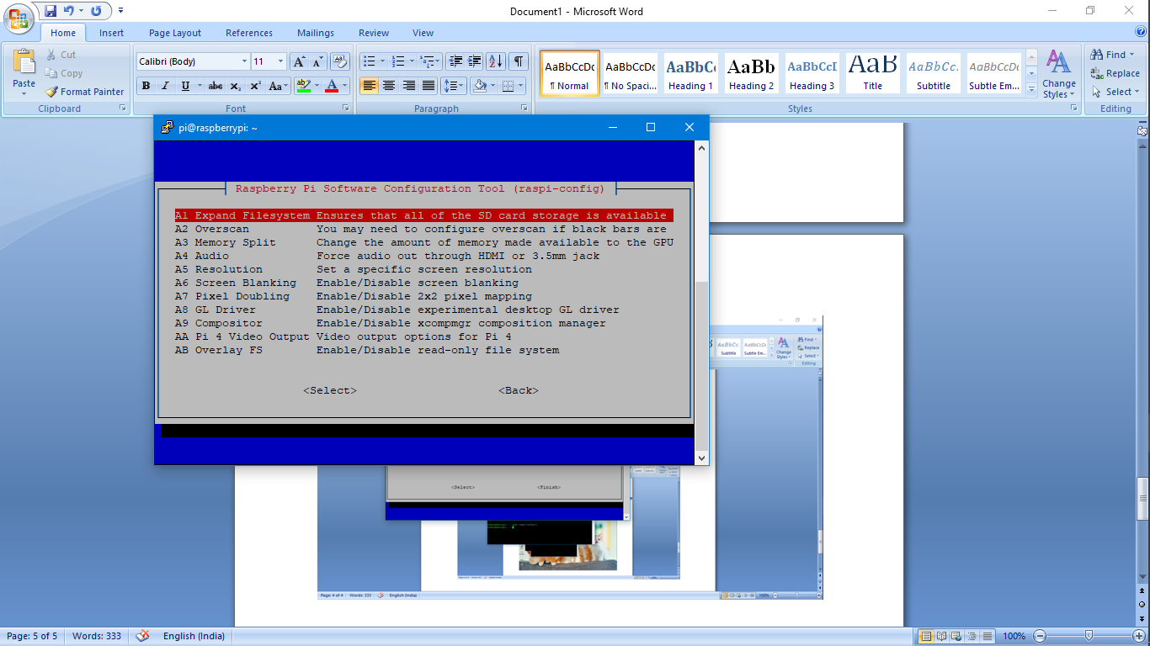**Follow Step by step given blew**

* **Enable the VNC mode**
* **Set the Resolution**

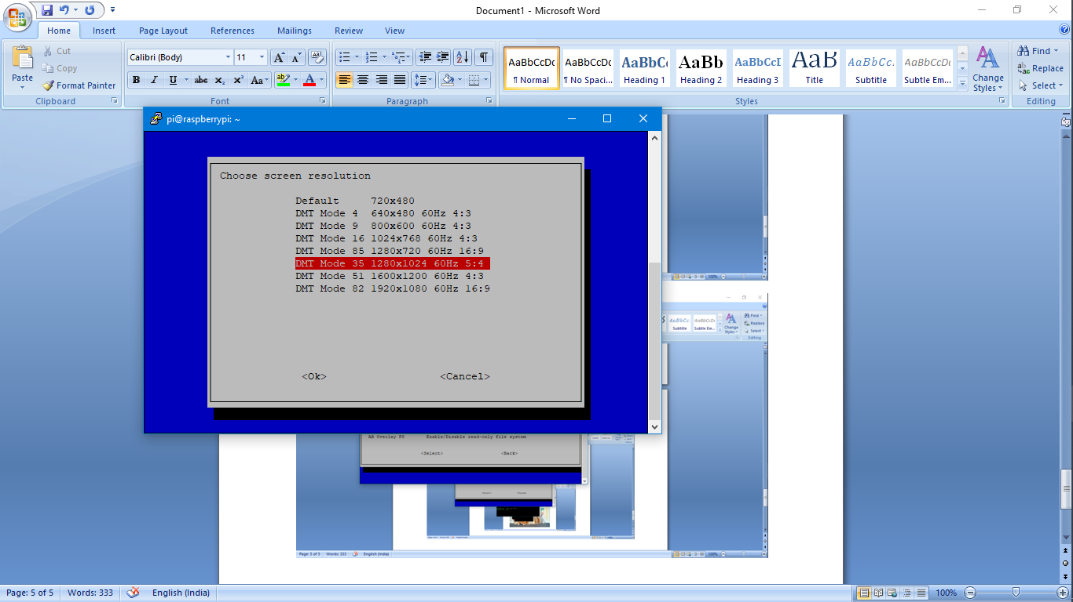 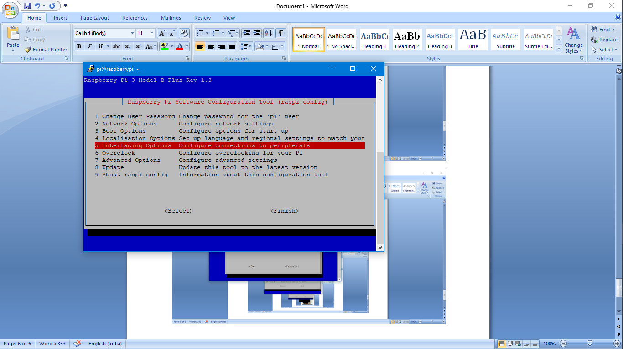  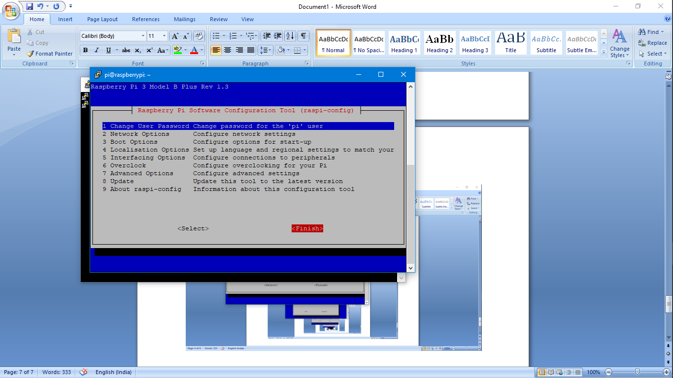

kgkjgg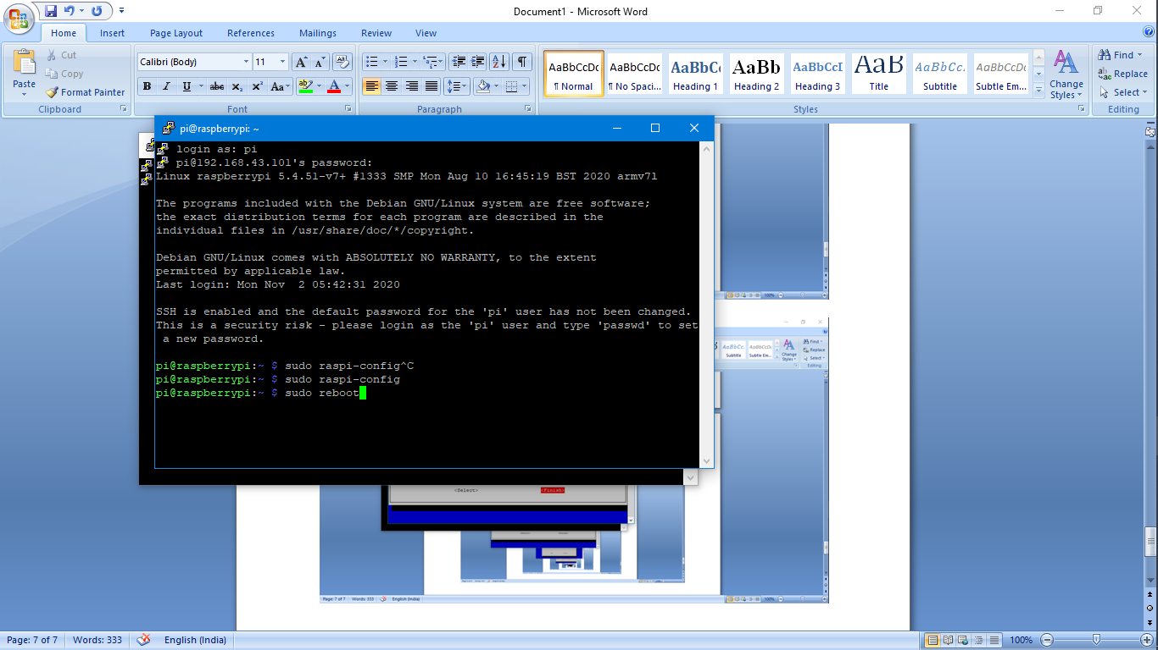

**Open VNC Mode than connect wifi network.**

